We will be using Raspberry Pi’s from now on. We have the [Raspberry Pi Model 3b+](https://www.raspberrypi.com/products/raspberry-pi-3-model-b-plus/)

**Important Information**

* At the end of every class you should backup your files in your google drive(more on that later)
* The raspberry pi’s do not have a power button.
* You have to shut down from the start menu (Start - Logout - Shut Down) or you can use the terminal with the command sudo halt.
* If you unplug your pi before it is completely shut down then there is a good chance that you will corrupt your memory card and lose everything on there
* It takes about 10 seconds for your pi to shut down. If you can see the green led then you will notice it flash quickly a few times, then stay on for about 1 second and then turn off. After that your pi is shut down and it is safe to unplug your power cord.
* To start your pi you just plug in the power cord, it is a micro USB port, so please be careful when inserting and removing the power cord.

The Start menu is in the top left corner.

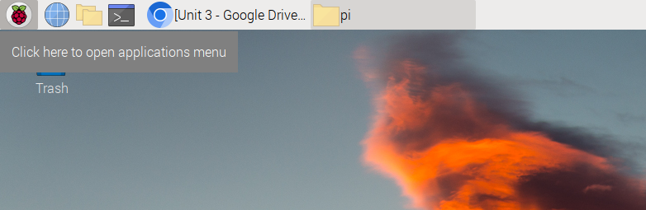

You can change the password using the Raspberry Pi Configuration(find it in the start menu). The default password is comsci2023, if you decide to change the password then you may also want to turn off auto login.

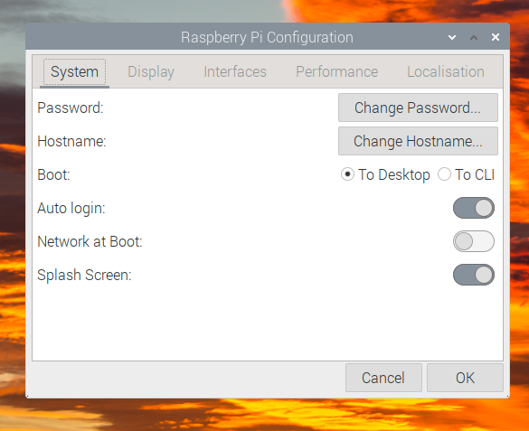

The file manager is where you will access your files. There are already folders for units 3,4, and 5. I would recommend that you use these folders to organize your files. There are subfolders inside each one to organize the activities, portfolios, and assignments. Everything will still be submitted using google classroom but this can help you keep everything organized.

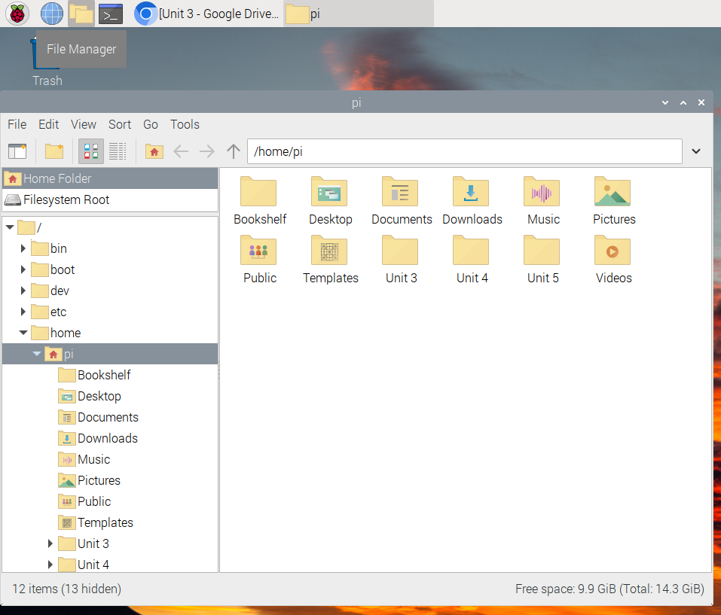

I recommend that you use either IDLE or Mu for creating your programs, they are both installed on your Pi already. They are in the Programming section in the start menu.

IDLE uses two separate windows. The Shell displays any output from your program and can be used to test commands. Your programs will be written in the second window, which you can open from the File menu.

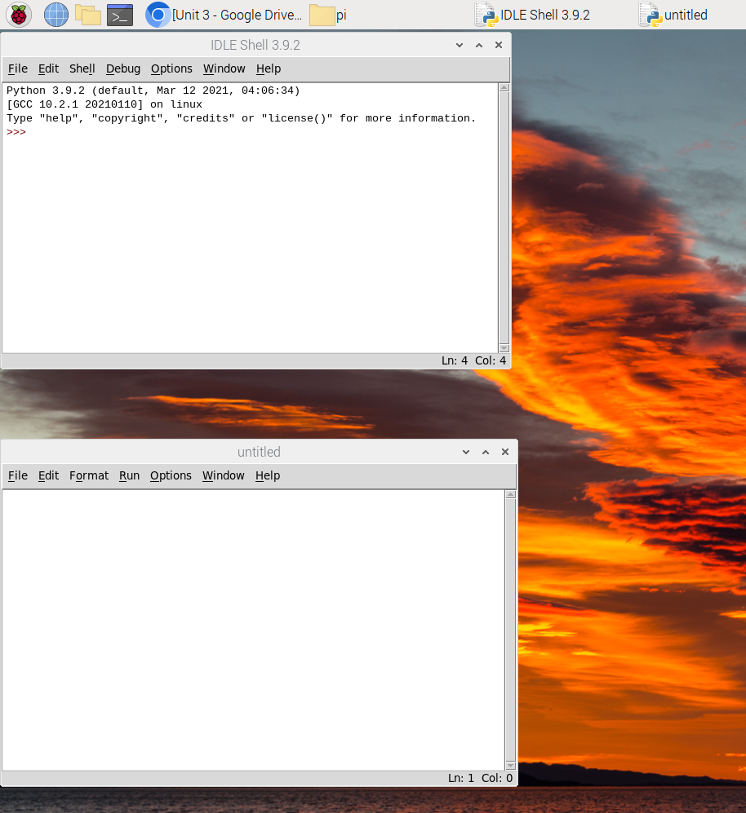

Mu contains everything in one window. One nice thing about Mu is that you can have multiple files open at one time and easily switch between them. Sometimes when you are switching between programs the names will get messed up, but they will correct themselves if you save the file again. When you run a program it will display in the bottom of the window. If you want to test commands you can change to the REPL screen(the button that looks like a keyboard(it will also display at the bottom of the window).

The first time you run Mu you will be asked what language you are using, select Python 3. There will also be a folder created in your home/pi directory(where the unit 3,4 and 5 folders are) for mu, I would still recommend using the folders that I put there for you.

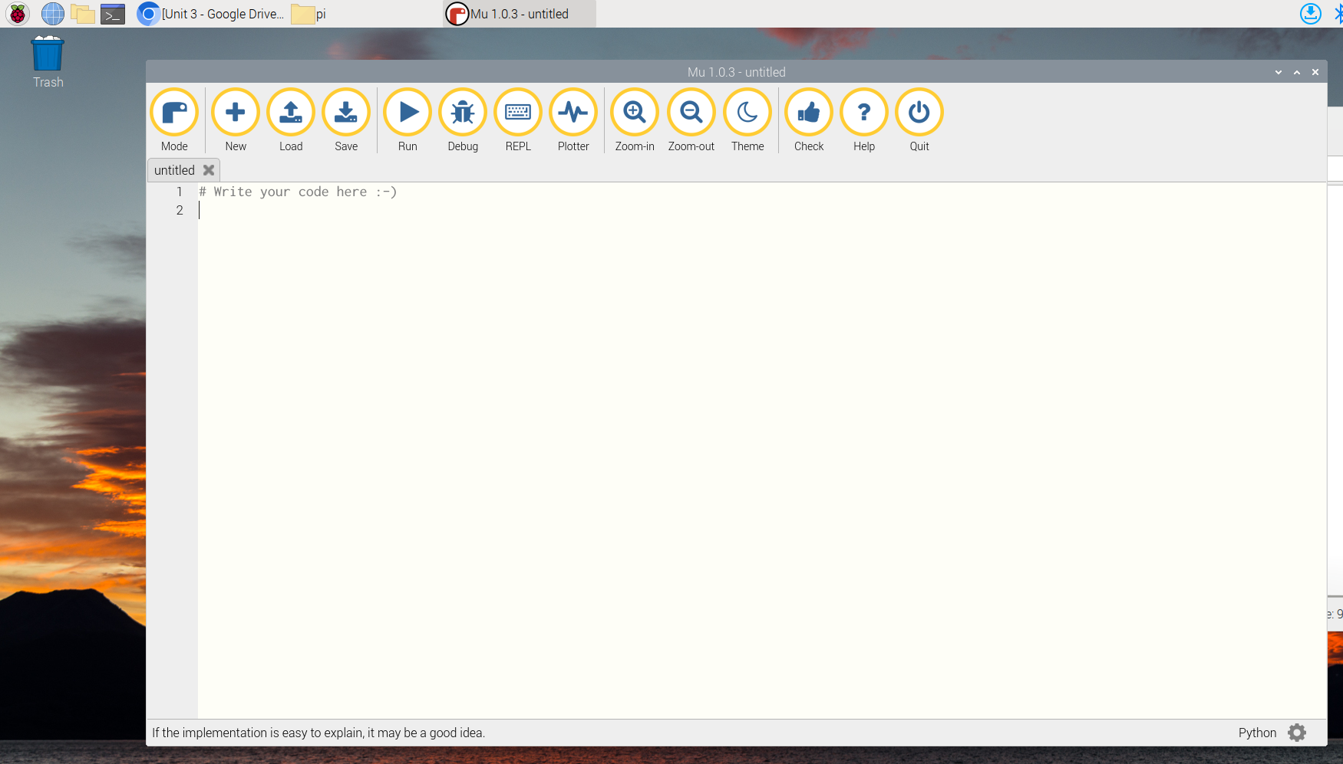

The terminal will need to be used occasionally. It is used to install new python modules. The shortcut to open it is ctrl + alt + t

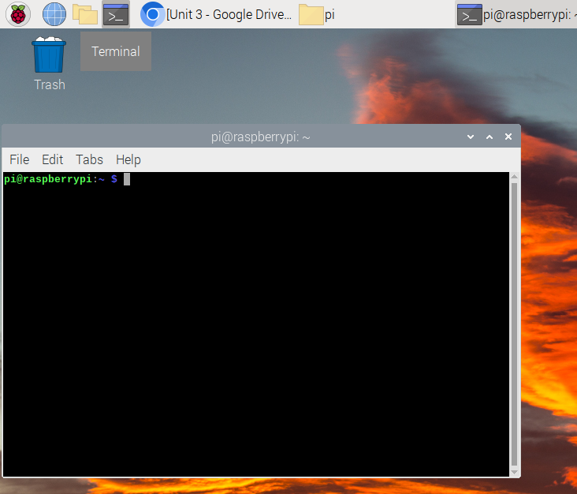

**Backing Up You Data(do this now)**

Open your web browser(the icon that looks like a globe) and sign into your google account. It is easiest to just go to gmail and sign in.

Open your Google Drive.

Create a new folder and call it Computer Science.

Open your Computer Science folder.

Open the File Explorer on your pi.

Select the Unit 3, Unit 4 and Unit 5 folders then drag and drop them into the Computer Science folder in your Google Drive.

In the future it may ask if you want to replace existing folders or keep both, you should select replace existing folders.

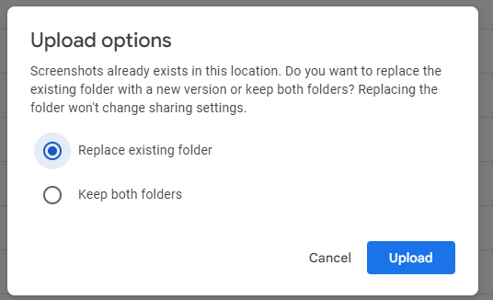

The last and most important thing is to realize that backing up your work is your responsibility and that you shouldn’t whine to Mr. Brake if you lose your work and have to start again because you didn’t back up your data.

**Installing Programs**

There are multiple ways to install programs on your pi.

* Using the Terminal. You have to enter a specific command.
  + sudo apt install the_program_name
* Using the add/remove software application(Start-Preferences)
* Using the Recommended Software application (Start-Preferences)

Install LibreOffice using the **Recommended Software** application. It is in the Office section.

This will take a little while. This particular application doesn’t install correctly from the terminal

**Accessing Course Material**

You can still access the course material using google classroom, but the pi’s are pretty slow when browsing the internet. I will also put the course material on github so you can easily download the notes, assignments, activities, portfolio projects and any other material.

To download all current course material you have to open a terminal and enter the following command.

git clone https://github.com/rob3662/Com_Sci_2023.git

This will create a folder called com_sci_2023 and download all the files I have posted on github

After the first time you will have to update the Com_Sci_2023 folder from github to get any changes. You have to go into the Com_Sci_2023 folder in the Terminal and pull the updates. Use the following commands. Note** Once you enter the C in the Com_Sci_2023 folder you can hit tab and it should enter the rest of the name for you.

cd Com_Sci_2023

git pull